**LAPORAN PRAKTIKUM DESAIN WEB**

“Tugas 03 -Layout, Font, dan Warna*”*



Oleh:

**Nama : Irmawati Pakpahan**

**NPM : 4523210054**

**Kelas : A**

Dosen:

**Adi Wahyu Pribadi , S.Si., M.Kom**

**S1-Teknik Informatika**

**Fakultas Teknik Universitas Pancasila**

**2023/2024**

**Link github :** [**https://github.com/IrmawatiPakpahan/Prak-DW/commit/f4fe4a6c8d14adf3266b04044d13392afa6b101f**](https://github.com/IrmawatiPakpahan/Prak-DW/commit/f4fe4a6c8d14adf3266b04044d13392afa6b101f)

**Capture style.css**

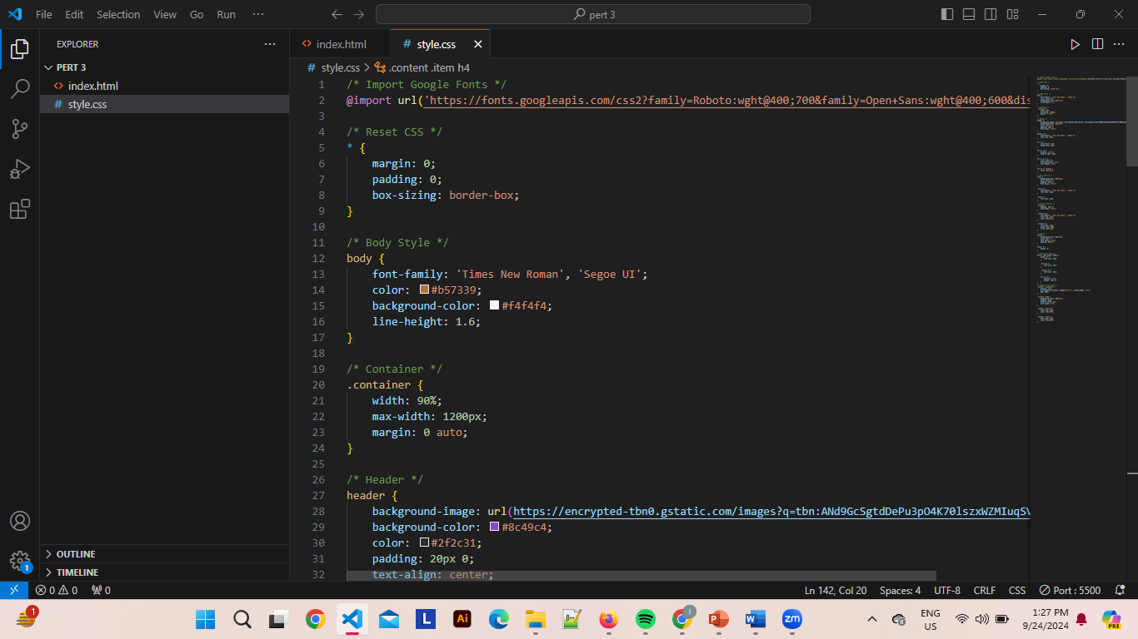

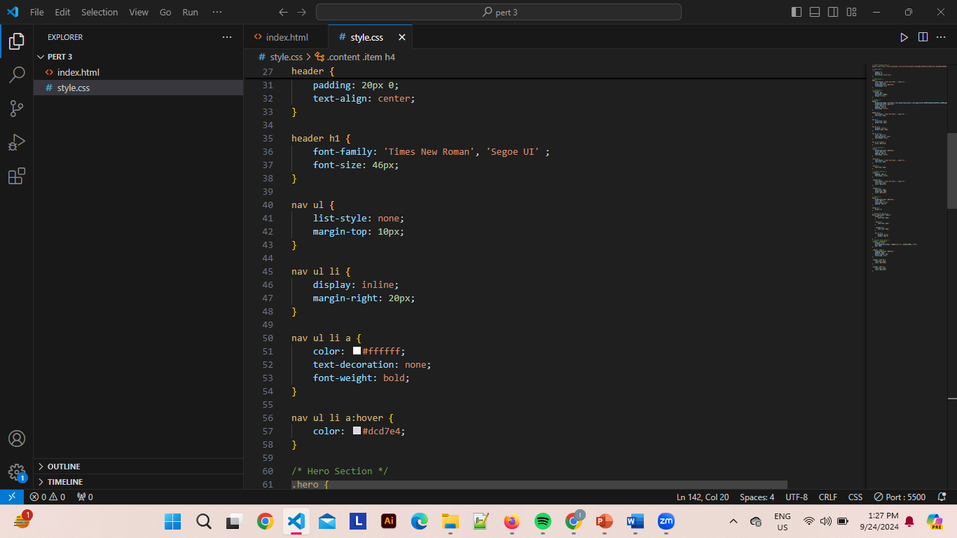

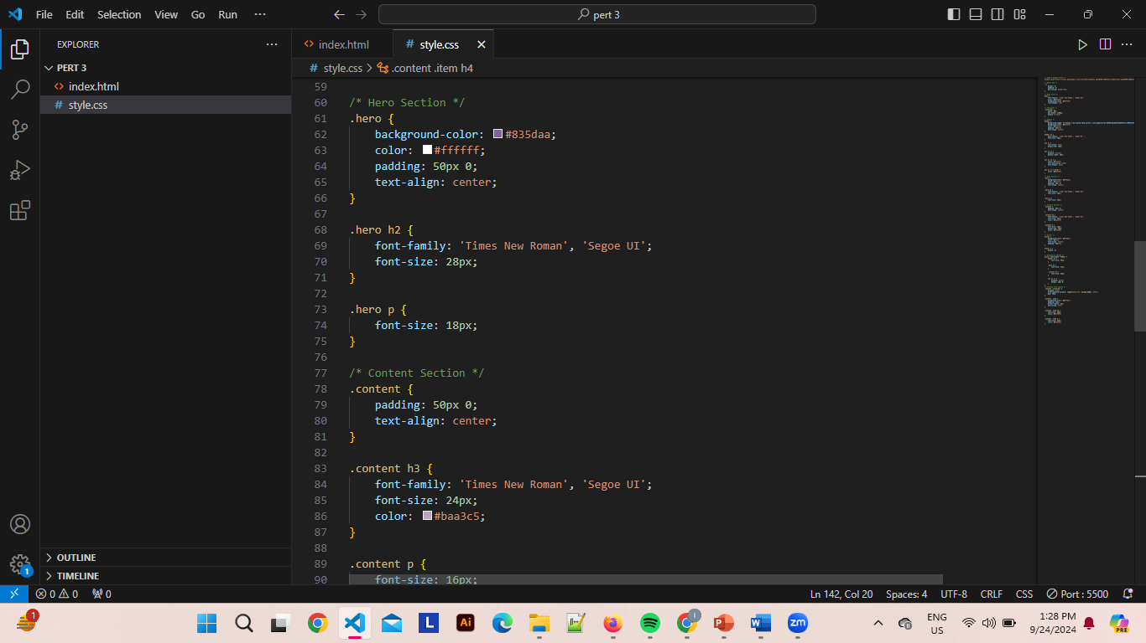

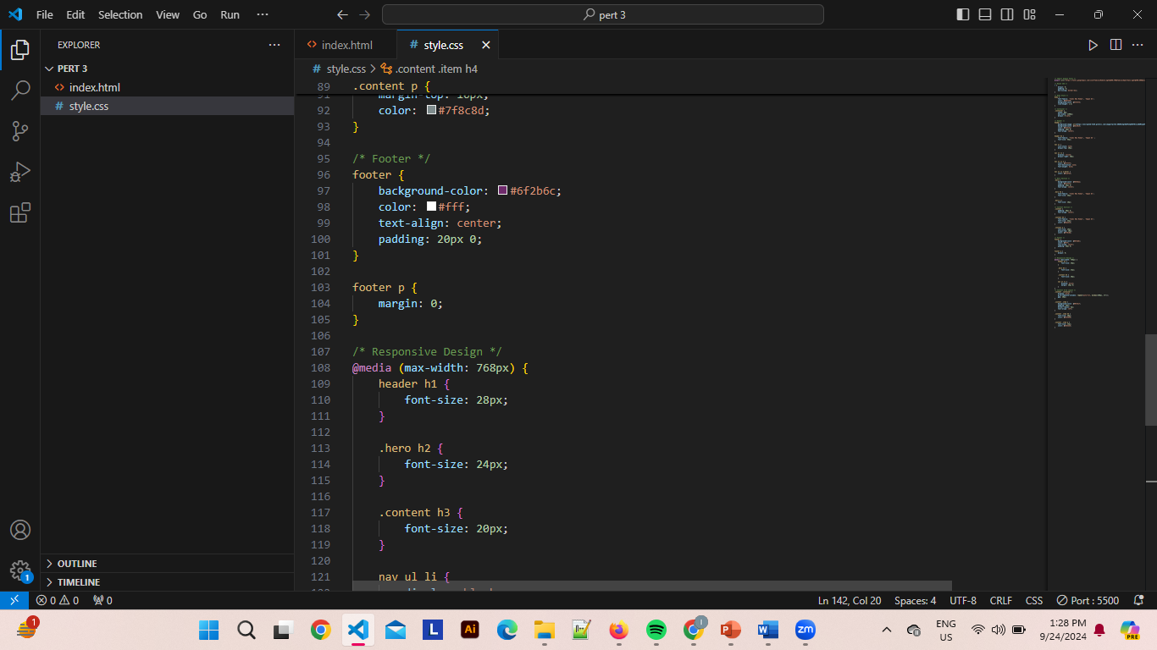

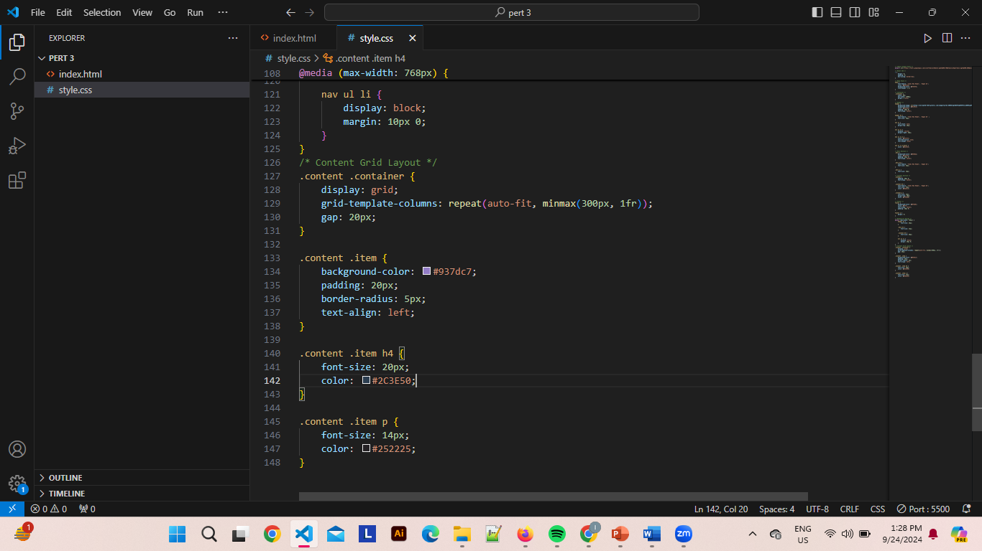

**Capture index.html**

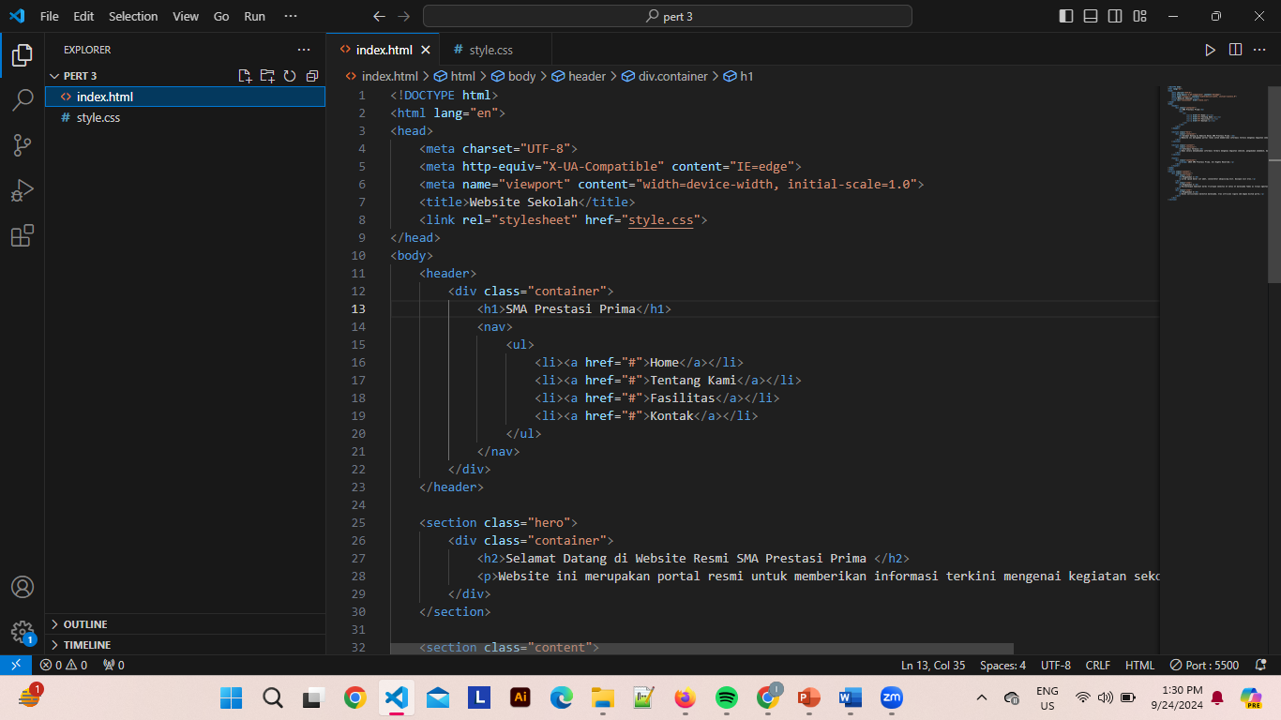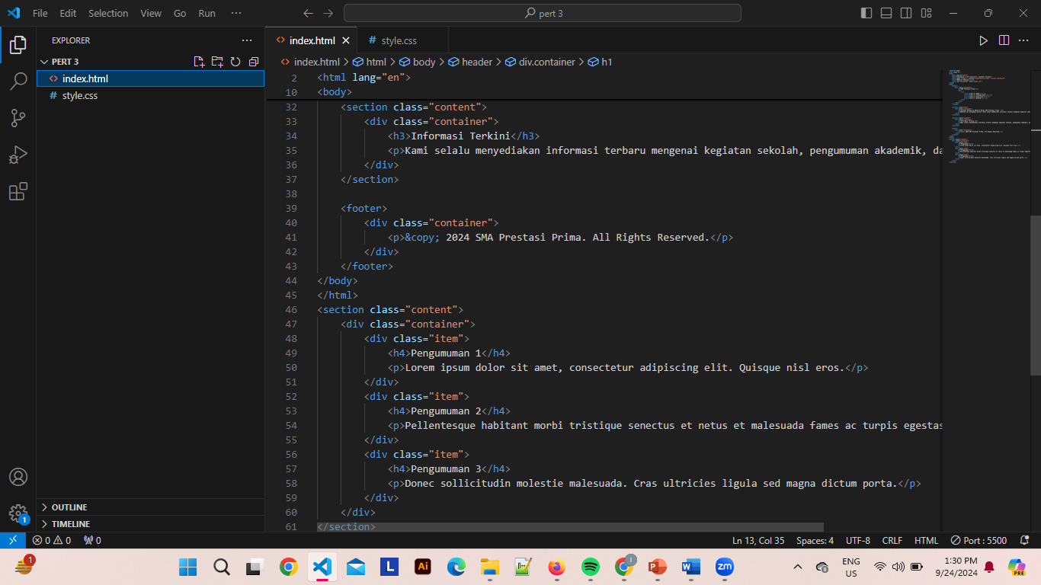

**Hasil**

